**Bar Break**

BarBreak is a platform that helps you overcome the language barrier and learn any language with ease. The system creates an interactive and playful experience that will motivate user to learn languages. BarBreak is based on the principles of effective and modern learning.

**Roles:**

|  |  |
| --- | --- |
| Role | Description |
| User | Register in a system, log in/log out, choose a course, view a description of a course, view content, enroll in a course, view a list of chose courses, edit chose courses. |
| Admin | Can view info about users. Edit user`s choice, create a course, add users to the system. |
| Guest | A user that isn't logged in. Can sing up and log in. |

**Course Management System**

|  |  |  |  |  |  |
| --- | --- | --- | --- | --- | --- |
| **№** | **Role** | **Use case** | **Description** | **Action name** | **Tests** |
| **1** | **User** | View a course | Can see the name of a course, its description and the content |  |  |
| **2** | Enroll for a course | Select a course. |  |  |
| **3** | Edit choice | Cancel their choice and enroll for another course. |  |  |
| **4** | View courses | View the list of courses that user chose. |  |  |
| **5** | Edit account | Edit personal information, delete an account, change a password. |  |  |

**Account Management System**

|  |  |  |  |  |
| --- | --- | --- | --- | --- |
| **№** | **Role** | **Use case** | **Description** | **Action name** |
| **1** | Guest | Sign up | Sign up in a system |  |
| **2** | Log in | Log in to a system |  |
| **3** | User | Log out | Log out of a system |  |

**User Management System**

|  |  |  |  |  |  |
| --- | --- | --- | --- | --- | --- |
| **№** | **Role** | **Use case** | **Description** | **Action name** | **Tests** |
| **1** | **Admin** | Edit user`s choice | Enroll for a course or cancel their choice and enroll for another course. |  |  |
| **2** | Create a course | Create a new course. Add information about the name of a course, its description and the content. |  |  |
| **3** | Delete a course | Delete a course from the system |  |  |
| **4** | Add user | Add a new user to a system |  |  |
| **5** | View courses | View the list of courses that user chose. |  |  |
| **6** | View users | View the list of users. |  |  |
| **7** | Manage user’s account | Edit personal information, delete an account, change a password |  |  |

**Use case diagram**

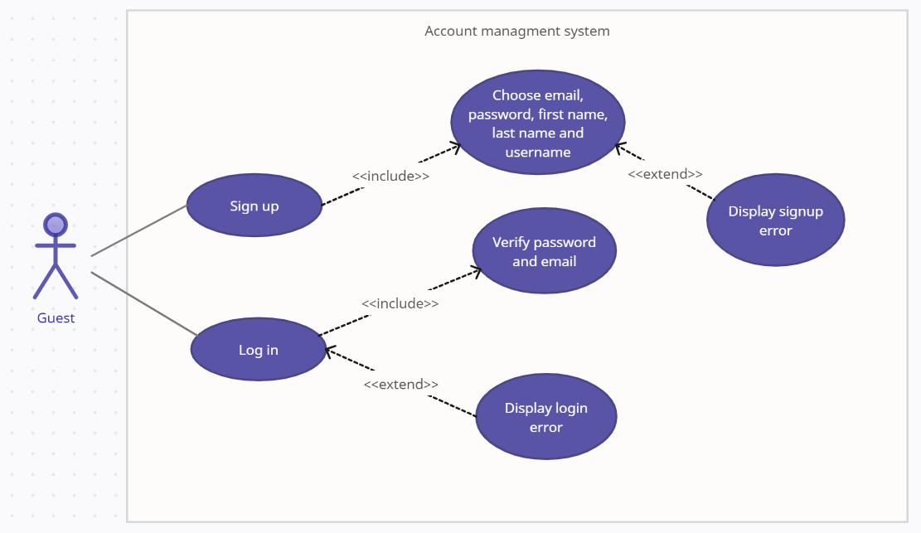

**Admin role use case diagram: Admin role use case diagram:**

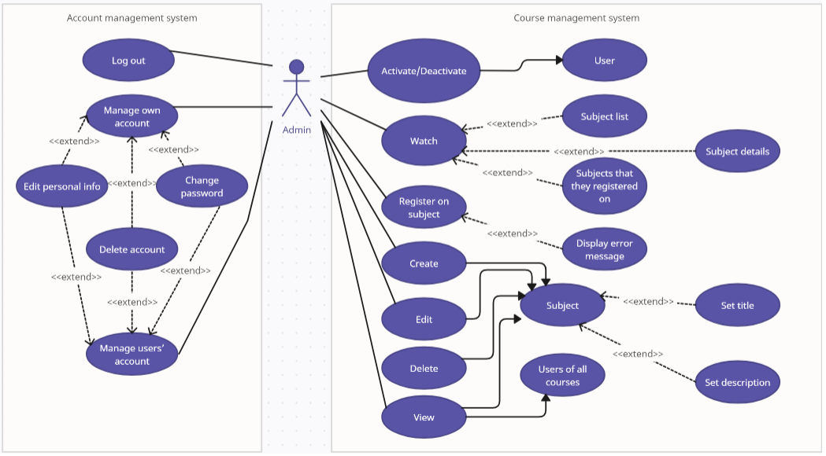

**User role use case diagram:**

